VLOGA ZA PRIDOBITEV SOGLASJA
za izvajanje turistične, športne ali rekreacijske dejavnosti na vodotokih in stoječih vodah, ki niso ribolov po predpisih, ki urejajo sladkovodno ribištvo, po 8. točki prvega odstavka 31. člena Zakona o Triglavskem narodnem parku (Uradni list RS, št. 52/10 in 46/14 – ZON-C 52/2010, 46/14 – ZON-C, 60/17, 82/20 in 18/23 – ZDU-10)

APPLICATION FOR CONSENT
to the carrying out of tourism, sports or recreation activities on streams or static surface waters that are not classified as fishing under the regulations governing freshwater fishing,
under point 8, paragraph one of Article 31 of the Triglav National Park Act
(Official Gazette of the Republic of Slovenia [Uradni list RS], Nos. 52/10 and 46/14 – ZON-C 52/2010, 46/14 – ZON-C, 60/17, 82/20 and 18/23 – ZDU-10)

1. PODATKI O IZVAJALCU DEJAVNOSTI (pravna ali fizična oseba) /
APPLICANT INFORMATION (the applicant may be a legal entity or a natural person)

Naziv podjetja oz. ime in priimek: / Title, name and surname:

Naslov / Address:
e-naslov / e-mail:
Odgovorna oseba / Authorised person (director):

Kontaktna oseba / Contact person:
e-naslov, telefon / e-mail, phone:

SOTESKANJE PREDELICA, FRATARICA: e-naslov za registracijo v spletni rezervacijski sistem / CANYONING PREDELICA, FRATARICA: e-mail for login to web canyoning reservation system:

Ime, priimek reševalca iz vode na divjih vodah / Name, surname of wild water rescuer |  | Ime, priimek vodnika  Name, surname of guide
1. |  | 1.
2. |  | 2.
3. |  | 3.
4. |  | 4.
5. |  | 5.
(če je reševalcev, vodnikov več, njihove podatke navedite v novem seznamu, ki je priloga vlogi) / (if there are several rescuers and guides, please provide their information on a separate list attached to this Application)

Vlogi prilagam kopije veljavnih izkaznic reševalcev iz vode na divjih vodah (program C) / I enclose a copy of valid Water Rescue ID Card (Program C)

2. PODATKI O NAMERAVANI DEJAVNOSTI: Vrsta dejavnosti, lokacija in namen izvajanja /
PLANNED ACTIVITY INFORMATION: Type of activity, location and purpose of activity

◻ soteskanje Predelica / canyoning in the Predelica | ◻ gospodarska dejavnost (vodenje gostov) / commercial activity (guiding)  ◻ zasebno obiskovanje / private visitation  ◻ drugo / other: _________________
◻ soteskanje Fratarica / canyoning in the Fratarica | ◻ gospodarska dejavnost (vodenje gostov) / commercial activity (guiding)  ◻ zasebno obiskovanje / private visitation  ◻ drugo / other: _________________
◻ soteskanje Jerečica / canyoning in the Jerečica | ◻ gospodarska dejavnost (vodenje gostov) / commercial activity (guiding)  ◻ zasebno obiskovanje / private visitation  ◻ drugo / other: _________________
◻ plovba* Sava Bohinjka / boating* on the Sava Bohinjka | ◻ gospodarska dejavnost (vodenje gostov) / commercial activity (guiding)  ◻ zasebno obiskovanje / private visitation  ◻ drugo / other: _________________
◻ plovba* Soča / boating* on the Soča | ◻ gospodarska dejavnost (vodenje gostov) / commercial activity (guiding)  ◻ zasebno obiskovanje / private visitation  ◻ drugo / other: _________________
◻ plovba* Koritnica / boating* on the Koritnica | ◻ gospodarska dejavnost (vodenje gostov) / commercial activity (guiding)  ◻ zasebno obiskovanje / private visitation  ◻ drugo / other: _________________
◻ potapljanje Soča / diving in the Soča | ◻ gospodarska dejavnost (vodenje gostov) / commercial activity (guiding)  ◻ zasebno obiskovanje / private visitation  ◻ drugo / other: _________________
◻ drugo / other:  _________________________ | ◻ gospodarska dejavnost (vodenje gostov) / commercial activity (guiding)  ◻ zasebno obiskovanje / private visitation  ◻ drugo / other: _________________

* plovba s plovili, ki so namenjena športni, rekreacijski plovbi (npr. raft, kajak, rečni bob, druga plovila) /
* boating in vessels intended for sports and recreation boating (e.g. rafts, kayaks, river sleighs, other vessels)

3. UPRAVNA TAKSA / ADMINISTRATIVE FEE
◻ | Vlogi prilagam dokazilo o plačilu upravne takse. (Za vlogo in izdajo soglasja se po Zakonu o upravnih taksah (Uradni list RS, št. 106/10 – ZUT-UPB5, 14/15 – ZUUJFO, 84/15 – ZZelP-J in 32/16, 30/18 – ZKZaš in 189/20 – ZFRO) plača upravna taksa v višini 22,60 EUR (obrazec UPN: Koda namena: TAXS, Namen plačila: plačilo upravne takse, IBAN: SI56 01100-1000315637, Referenca: SI11 25429-7111002-35616, Ime in naslov: Upravne takse – državne, 1000 Ljubljana)  I enclose confirmation of payment of administrative fees. (In accordance with the Administrative Fees Act (Official Gazette of the Republic of Slovenia, Nos. 106/10 – ZUT-UPB5, 14/15 – ZUUJFO, 84/15 – ZZelP-J, 32/16, 30/18 – ZKZaš in 189/20 – ZFRO), the application and issuance of the consent is subject to an administrative fee in the amount of EUR 22.60 (universal payment order (UPN) form: Code purpose: TAXS, Payment purpose: Payment of administrative fee, IBAN: SI56 01100-1000315637, Reference: SI11 25429-7111002-35616, Title/Name and address: Upravne takse – državne [Administrative Fees – national], 1000 Ljubljana).

Datum / Date: ___________________ |  | Podpis / Signature: ____________________________

Navodilo za izpolnjevanje vloge / Instructions for filling out the application form

- PODATKI O IZVAJALCU DEJAVNOSTI / APPLICANT INFORMATION
Navedite točne podatke o vložniku. V primeru pravne osebe navedite podatke, ki poleg naziva, imena odgovorne osebe, sedeža, pošte in e-naslova pravne osebe vključujejo tudi podatke o kontaktni osebi. Navedite e-naslov za dostop do sistema spletne prodaje pristojbin za soteskanje v soteskah Fratarice in Predelice. Ob izdaji soglasja boste na navedeni e-naslov prejeli uporabniško ime in geslo za dostop do sistema spletne prodaje pristojbin. V primeru izvajanja soteskanja z namenom gospodarske dejavnosti (vodenje gostov) napišite imena in priimke vseh predvidenih reševalcev iz vode na divjih vodah ter vodnikov (v kolikor ne gre za iste osebe). Vlogi obvezno priložite kopije veljavnih izkaznic reševalcev iz vode na divjih vodah. V kolikor na obrazcu ni prostora (je več kot pet reševalcev, vodnikov), njihove podatke navedite v novem seznamu, ki je priloga vlogi. Skladno z zakonodajo morajo osebe, ki opravljajo dejavnost raftinga, kajakaštva, soteskanja in drugih dejavnosti na vodah s pridobitnim namenom, za vsako skupino udeležencev zagotoviti prisotnost reševalca iz vode na divjih vodah. Slednje je tudi pogoj za pridobitev soglasja za izvajanje soteskanja v Fratarici in Predelici, kjer uvajamo sistem spletne prodaje pristojbin.

Provide accurate information about the applicant. If the applicant is a legal entity, please provide its name, address of registered office, authorised person, e-mail address, as well as details about the contact person. For canyoning in the Predelica and the Fratarica provision of e-mail address is compulsory because it enables the use of online reservation system for canyoning in the Predelica and the Fratarica. Once your consent has been issued, you will be sent a user name and a password to the e-mail address given. In the case canyoning will be carried out as a commercial activity (guiding), please provide the name(s) and surname(s) of all certified wild-water-rescuers and guides (if not rescuers) in the team. If there are more than 5 rescuers, guides, their information should be written on a separate sheet of paper and submitted with the application. Copies of the valid Water rescue ID Card(s) are mandatory. According to the Slovenian legislation all legal entities carrying out rafting, kayaking, canyoning and other activities on waters as commercial activity, should provide the presence of a wild-river-rescuer for each group. The latter is also mandatory for issuing the Triglav National Park Consent for canyoning in the Predelica and the Fratarica.

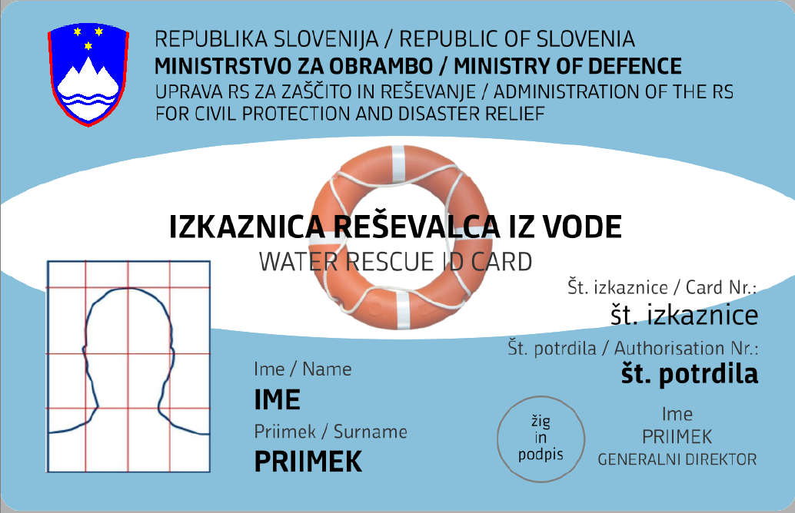 | 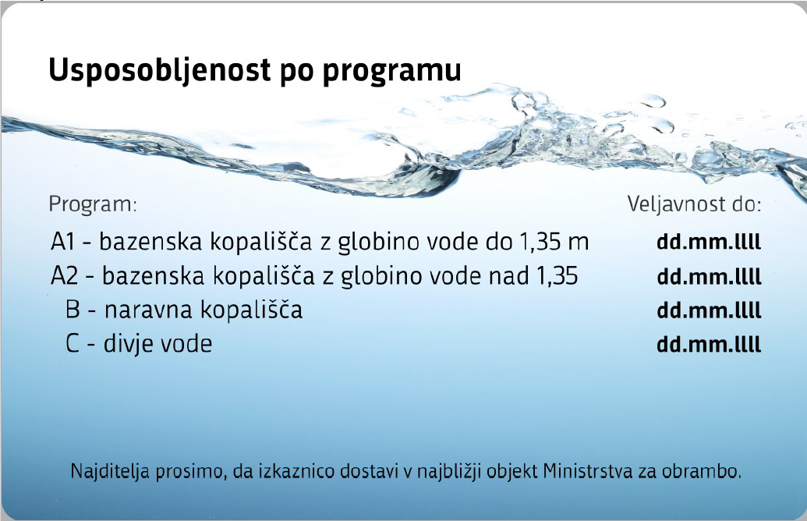

- PODATKI O NAMERAVANI DEJAVNOSTI / INTENDED ACTIVITY INFORMATION

Vrsta dejavnosti, lokacija in namen izvajanja dejavnosti / Type of activity, location and purpose of activity
Označite kje in katere dejavnosti boste izvajali ter s kakšnim namenom. / Please indicate what activities you will carry out, where, and the reason for carrying out the activity.

- UPRAVNA TAKSA / ADMINISTRATIVE FEE
Vlogi priložite dokazilo o plačilu upravne takse!
Za vlogo in izdajo soglasja se po tarifnih številkah 1 in 3 taksne tarife Zakona o upravnih taksah (Ur. l. RS, št. 106/10 – ZUT-UPB5, 14/15 – ZUUJFO, 84/15 – ZZelP-J, 32/16, 30/18 – ZKZaš in 189/20 – ZFRO) plača upravna taksa v višini 22,60 EUR (obrazec UPN: Koda namena: TAXS, Namen plačila: plačilo upravne takse, IBAN: SI56 01100-1000315637, Referenca: SI11 25429-7111002-35616, Ime in naslov: Upravne takse – državne, 1000 Ljubljana).

Please submit proof of payment of the administrative fee with your application!
In accordance with the tariff no. 1 and 3 of the Administrative Fees Act (Official Gazette of the Republic of Slovenia, Nos. 106/10 – ZUT-UPB5, 14/15 – ZUUJFO, 84/15 – ZZelP-J, 32/16, 30/18 – ZKZaš and 189/20 – ZFRO), the application and issuance of the consent is subject to an administrative fee in the amount of EUR 22.60 (universal payment order (UPN) form: Code purpose: TAXS, Payment purpose: Payment of administrative fee, IBAN: SI56 01100-1000315637, Reference: SI11 25429-7111002-35616, Title/Name and address: Upravne takse – državne [Administrative Fees – national], 1000 Ljubljana).

